Lab: Storing and Accessing Templates with Git and GitHub

Outcome
You will create a GitHub repository for this course. This is the repository you will use to commit your application files to as you perform your assignments.

Resources Needed
- Web Browser

Level of Difficulty
Easy

Deliverables
- You will submit a Word document with the required screenshot.
- NOTE: If you do not have a GitHub account, please follow the steps in Create an Account. If you already have an account, skip to the section titled Uploading to GitHub.

Create an Account
- Navigate to https://github.com/
- Click on Sign up.
- Follow the on-screen instructions to create an account. You will need to enter an email, username, and password. Since this will be your personal GitHub account, we recommend using your personal e-mail account name and address.
- Check your email for the verification code. Once you receive the email, go back to GitHub to enter the verification code. Click Skip Personalization when prompted.

Uploading to GitHub
NOTE: There may be slight differences in your interface. Refer to the GitHub documentation if you have difficulties with any of the following steps.

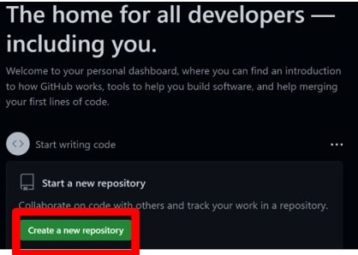
- Click on Create a new repository or New (if you already have repos in your GitHub account).
OR
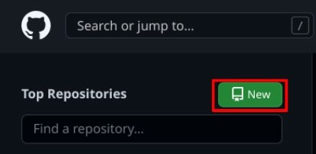

- Enter CYB260L for the repository name, add a short description, select the “Private” option, then click Create repository.
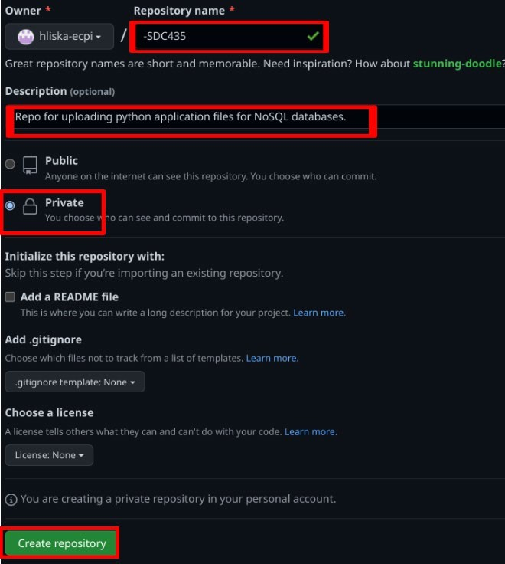
- Click on README.

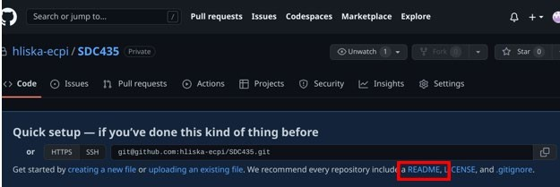

- In the “Edit new file” tab, type the course code and your personal student ID. Click on the Preview
tab to verify the information is correct, and then click Commit changes.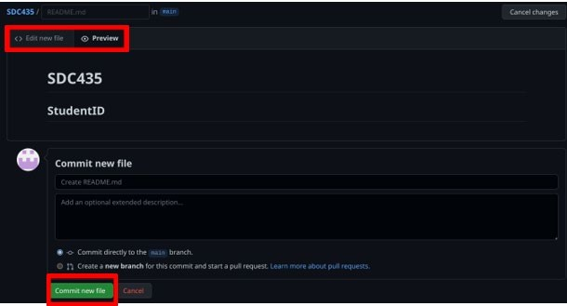

- Take a screenshot of your commit (similar to the image below) and add it to your lab assignment report. It should show your GitHub username, the uploaded files, the commit code, and when your files were uploaded.
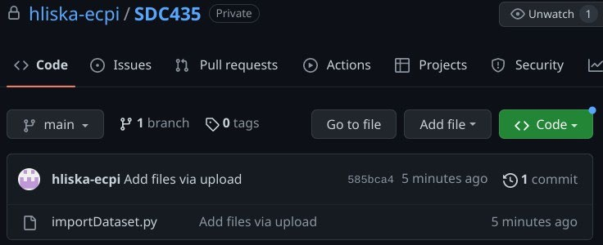

- Click on the Add file tab, then again on the Upload files option.
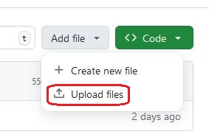
- Navigate to the directory where you saved your created template files from the first unit. Select all of the files, then click Open.
- Back in the GitHub repository page, ensure that all of the files you selected are displayed. If they are not repeat the last 3 steps until all files appear. Click on Commit changes.

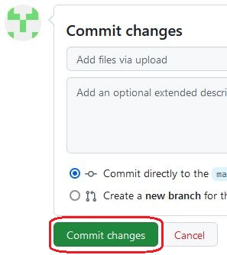

Downloading, Installing and Configuring Git

- On your local system, open a web browser and navigate to https://git-scm.com/downloads

- Download the correct version of Git for your operating system.

NOTE: If you are running MacOS or a Linux distribution on your desktop system, Git is likely already installed.

- Install your downloaded copy of Git. On the Choosing the default editor used by Git page, change your option to match the text editor you used previously when creating your template files. Accept all other default settings.
- Once Git is fully installed, create a new directory on your system that can serve as the root folder for the local Git repository. Name this directory CYB260L.
- Right-click your CYB260L directory, then click to select the Open Git GUI here option. From there, click Clone Existing Repository.
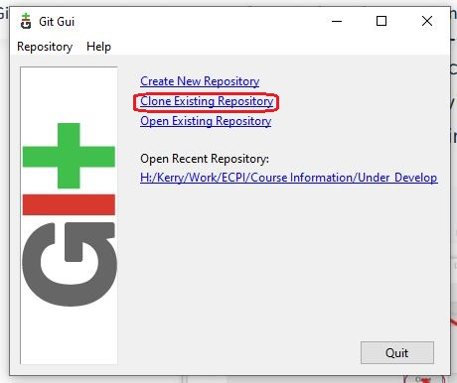

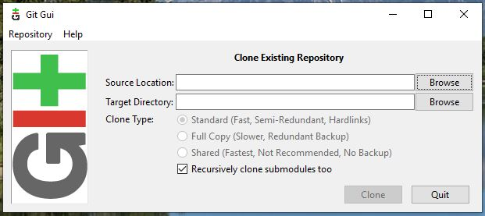

- Inside the Clone Existing Repository window you will need to populate the Source Location: with the repository path (URL) you created in GitHub.

- For the Target Directory, click Browse. Navigate to the path of the CYB260L directory then click Select Folder.

At the end of the Target Directory path, add another folder (that does not yet exist) called GitHub.

- With both the Source Location and Target Directory lines populated, click Clone.

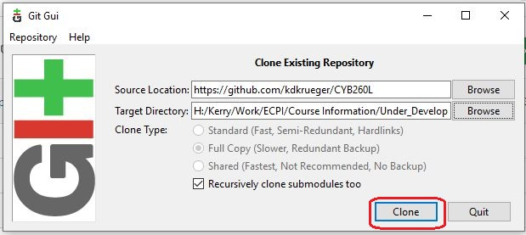

Note: Your information will be different from the example below. Click Clone.

- When prompted, sign in to GitHub. Click on Authorize git-ecosystem, then enter your GitHub password and click Confirm.

- Open the GitHub directory you created on Step 15, then create a screen shot of its contents (see example). You should see each of the template files uploaded to your GitHub account created earlier. Add your screen shot to your assignment submission report.

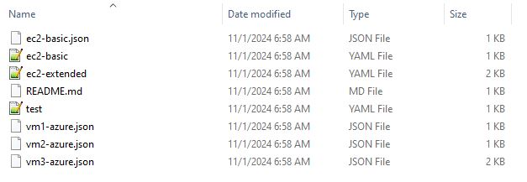

END OF ASSIGNMENT

